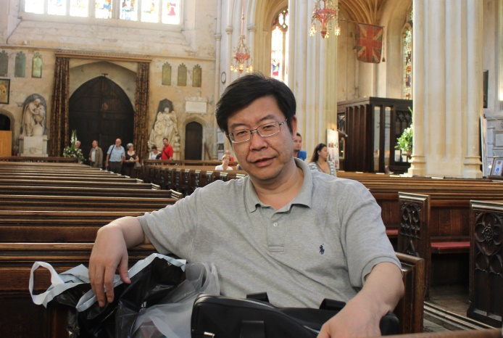
Wei Zhong, a senior research fellow in the institute of economics, Chinese Academy of Social Sciences, who is also the standing vice-president of the Association of China Economic Thought History, Executive Director of The Association of Labor Economy, the Director of China Economic Transition and Development Center of Institute of Economics, CASS.
He got his MA degree from school of economics in Peking University in 1991, then he join the institute of economics, CASS. In 2003, he got his Ph. D degree from department of economics of the graduate school of CASS.
Since 1996, he involved in income distribution and relevant issue research. His main research interest includes: income distribution, labor market, regional economic development, etc. And have done a lot of policy research for different ministries and central government.
He involved in several international collaboration projects, and made presentation in international academic workshops and conferences. He has ever been a guest research fellow in India-China institute of the New School(2008-2010) and visiting professor in Nagoya University(2009).
Main publication:
How and why has poverty changed in China: A study based on micro data for 1988 and 1995. China Quarterly, 2000, 164. (Cooperated with Bjorn Gustafsson)。
The Role of Health on Off-farm Employment and Wage Decision, Economic Research Journal (in Chinese). 2004(2).
The Distribution of Wealth in Urban China and in China as a Whole in 1995, Review of Income and Wealth, Series 52, Number 2, June 2006. (in Chinese, Cooperated with Bjorn Gustafsson and Li Shi).
Current Income Distribution Status in China and Its Policy Implication, Economic Perspectives, Issue 8, 2010.(in Chinese)
Analysis on 2000-2011 China’s National Income distribution----based on fund flow statements, Economic Perspectives, Issue 11, 2014. ( in Chinese)
Inclusive Development and Policy Choices towards Social Justice, Economic Management Press, 2013. (in Chinese, co-eds.).

